Park Host Manual

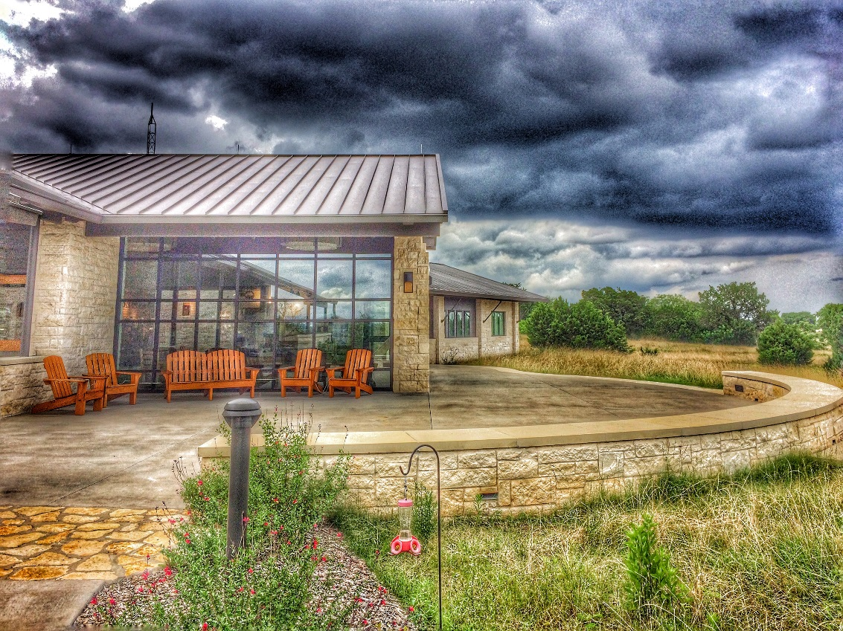

Mother Neff State Park

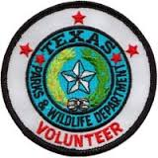

Texas State Parks Mission to manage and conserve the natural and cultural resources of Texas and to provide hunting, fishing and outdoor recreation opportunities for the use and enjoyment of present and future generations.

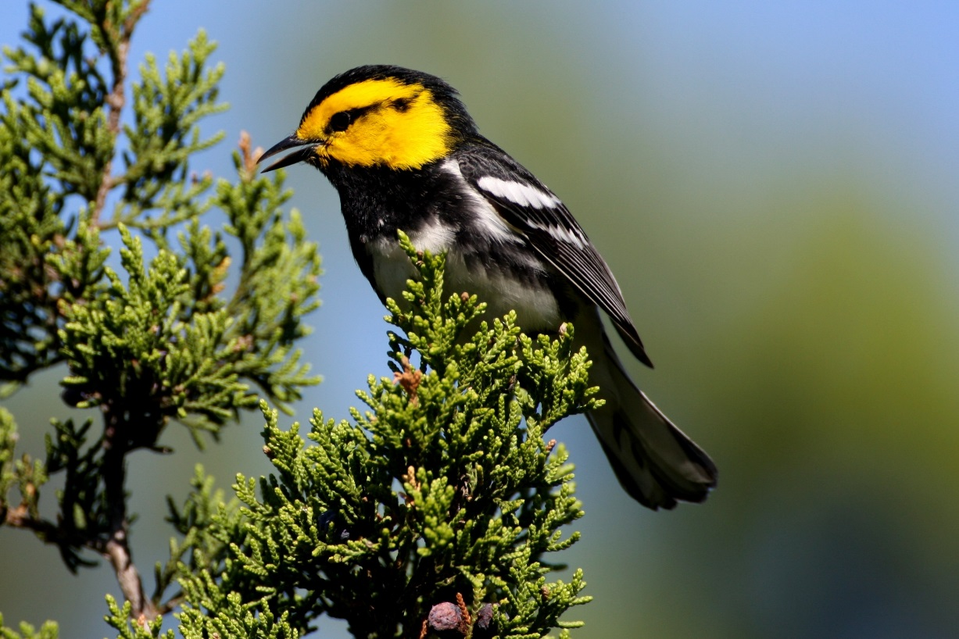

Golden-Cheeked Warbler. Mother Neff State Park is home to this endangered species in the summer. This park has a mature juniper-oak forest which is the preferred nesting habitat for this species.

History
The Texas Parks and Wildlife Department (TPWD) provides outdoor recreational opportunities by managing and protecting wildlife and wildlife habitat and acquiring and managing parklands and historic areas. It has inherited the functions of many state entities created to protect Texas’ natural resources. In 1895 the legislature created the Fish and Oyster Commission to regulate fishing. The Game Department was added to the commission in 1907. The State Parks Board was created as a separate entity in 1923. In the 1930’s, projects of the federal Civilian Conservation Corps (CCC) added substantially to the state’s parklands. In 1951, the term oyster was dropped from the wildlife agency’s name, and in 1963, the Parks Board and the Game and Fish Commission were merged to form the Texas Parks and Wildlife Department. The legislature placed authority for managing fish and wildlife resources in all Texas counties with the Texas Parks and Wildlife Department when it passed the Wildlife Conservation Act in 1983. Previously, commissioner’s courts had set game and fish laws in many countries, and other counties had veto power over department regulations.

Mother Neff SP Addendum Table of Contents
Mother Neff State Park Host Manual Addendum…………………………………………………….. Tab 2
Park Fee Sheet………………………………………………………………………………………………………….. 4
Park Key Points of Contact………………………………………………………………………………………… 5
Safety………………………………………………………………………………………………………………………… 6
In Case of Emergency (Medical & Maintenance)……………………………………………………….. 6
Mother Neff SP Emergency Management Plan………………………………………………………….. Tab 3
Park Specific Hazards & Safety…………………………………………………………………………………… 7-8
TPWD Safety Manual…………………………………………………………………………………………………. Tab 4
Job Specific Information…………………………………………………………………………………………….. 9
Host Job Duty Description………………………………………………………………………………………….. 9
Sample Evaluation Form…………………………………………………………………………………………….. 10
Push to talk Radio Instructions…………………………………………………………………………………… 11
Restroom Cleaning Instructions………………………………………………………………………………….. 12
Sample Schedule………………………………………………………………………………………………………… 13
Timesheet Form…………………………………………………………………………………………………………. 13
Park Information………………………………………………………………………………………………………… 14
Selected Park Rules and Regulations…………………………………………………………………………… 14
Area Resources List…………………………………………………………………………………………………….. 16-19
Area Attractions List……………………………………………………………………………………………………. 19-20
Park FAQ’s Page…………………………………………………………………………………………………………… 20-25
Host Equipment Check-Out List and Acknowledgement………………………………………………. 26

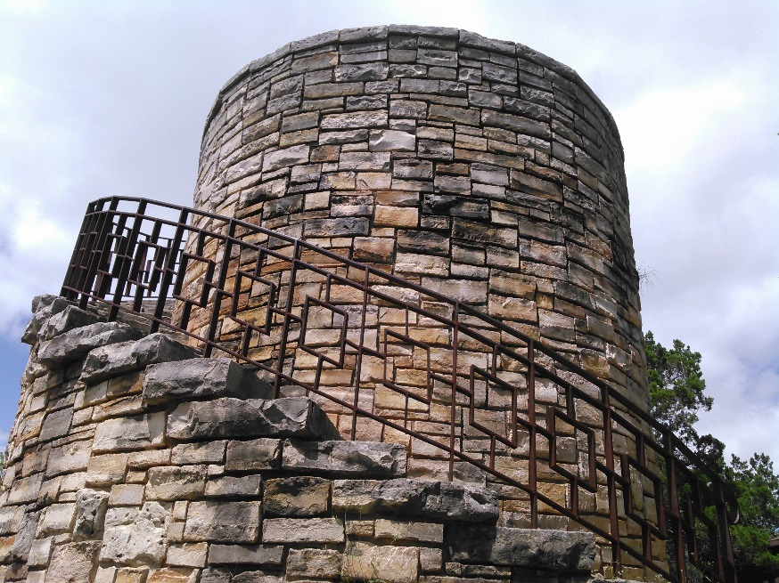
Civilian Conservation Corp – Rock Tower

Park Fee Sheet
Daily Entrance Fees
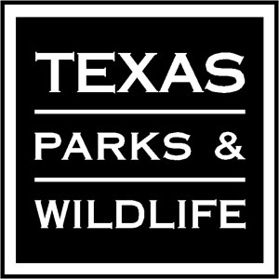
Entry Fee
- $2.00 per person 13 and over
- Children 12 and under are free

Park Passes
Bluebonnet Disabled Veteran Pass
- FREE
- 60% service disability as veteran with award letter
- Entrance fee waived for card holder and one individual

Texas State Parks Pass

- $70.00 for 1 person
- $25.00 for additional pass
- waives entry fees for entire vehicle
(up to 15 people)
- 4 camping coupons for 1/2 off one
night with minimum two night stay
- 10% off gift store items.
- Good for 1 year

Bluebonnet Partial Pass
Bluebonnet Disabled Pass
- Free
- 1/2s off entrance fee (rounded to next whole dollar
- Benefit Award Letter from SSA required
- Good for 1 year

Youth Group Annual Pass
- $100.00
- Entrance fee waived for up to 50 people
- Good for 1 year
- Apply on TPWD website. Not available at parks.

- FREE
- 1/2 off entrance fee (rounded to
next whole dollar)
- Seniors 65 and over Texas
Resident only
- Must present ID to receive pass

Facility Fees
Camping Fees
CCC Campground Multi-Use Sites
Group Picnic Pavilion “Rock Tabernacle”
- $80 per day + entrance fee
- Open air pavilion with a seating capacity of 96, total capacity is 250.
- Water in the area
- Restrooms in the area
- Large outdoor grill
Cabin with Campsite (Group Facility)
(CCC Cabin)
- Fri. – Sun - $250 per night
Mon. – Thurs $160 per night
- 16-person limit – 8 sleeping inside and 8 sleeping outside in tents.
- ADA accessible
- Central A/C and heat
- Furnished living area
- four bedrooms
- Picnic tables
- No TV, Internet or phone
- Check in 3 p.m., check out 11 a.m.
- 6% occupancy tax

- $25 per night + entrance fee
- 20 sites
CLOSED
- 50/30 amp at each site
- Sewer at each site
- Water at each site
- Bathhouse in the area
- Limit 8 people per site

River Bottom Tent Sites
CLOSED
- $12 per night + entrance fee
- 15 sites
- Water in the area
- Restrooms in the area
To make reservations for campsites/facilities
Call (512) 389-8900 or visit www.texasstateparks.org
CLOSED
Group Picnic Pavilion 3 “Wood Tabernacle”
- $30 per day + entrance fee
- Open air pavilion
- total capacity 32
- Water in the area
- Restrooms in the area
- Large outdoor grill
CLOSED
Group Picnic Pavilion “Breezeway”
- $40 per day + entrance fee
- Covered patio; picnic tables
- Seating capacity 32; total capacity 50
- Water in the area
- Restrooms in the area
- Large outdoor grill
Key Points of Contact:

Superintendent: Melissa Chadwick
Phone: (254)853-2389 ext. 224, Radio #471
Cell: (254) 717-7260
Email: Melissa.Chadwick@tpwd.texas.gov

Park Police Officer: Jeremy Gann
Cell: (254)228-7564 Radio #4877
Email: Jeremy.Gann@tpwd.texas.gov

Maintenance Supervisor: Diego Aragon
Cell: (254)313-8933 Radio # 478
Email: Diego.Aragon@tpwd.texas.gov

Office Manager: Jaime Harman
Phone: (254)853-2389 ext.221
Radio # Mother Neff
Email: Jaime.Harman@tpwd.texas.gov

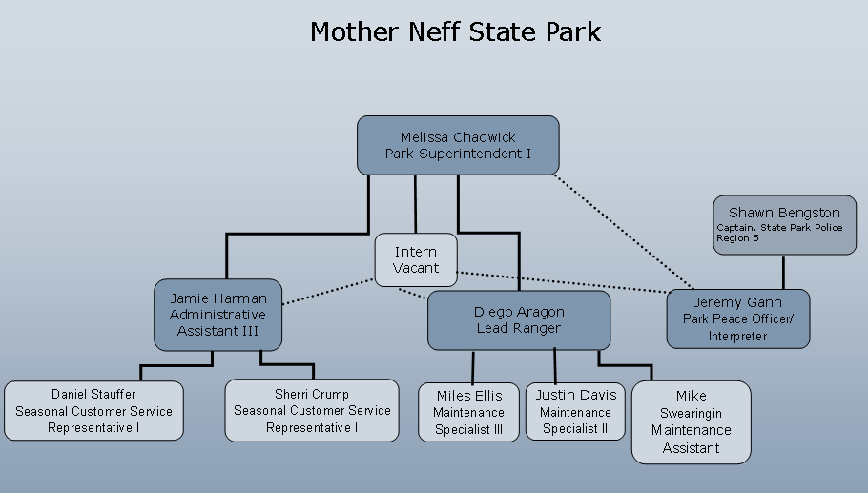

Safety

In Case of Emergency
Medical Emergency
For serious or life threatening injuries or illnesses, call 911 first and request EMS so that they are in route as soon as possible. Then contact Park Headquarters, the Park Superintendent or Park Police Officer. We are in Coryell County and will need to be dispatched to the Coryell County Sheriff’s Department. Specify what area of the park you are located in.

After Hours Maintenance Emergency
If there is a maintenance emergency after hours, call the on-call staff member, lead ranger, maintenance supervisor, or park superintendent (see Contact List). Not all maintenance issues are emergencies. Any issue that threatens the health or safety of visitors, staff, or volunteers or could lead to major damage to park resources should be reported immediately. All non-emergency issues should be reported to the appropriate staff the next day. For example, a maintenance emergency is flooding of the bathrooms. In this circumstance, call the on-call staff member (or next available staff), turn off the water, and lock the restrooms. A non-emergent maintenance issue is a clogged toilet. In this circumstance, post an out of order sign on that stall and notify staff the following morning.

Emergency Contact Information
Emergency…………………………………………………………….. 911
Park Police Officer Jeremy Gann……………………………. (254)228-7564
Coryell Sheriff’s Office…………………………………………… (254)865-7201
Park Headquarters…………………………………………………. (254)853-2389
Park Superintendent Melissa Chadwick…………………. (254)717-7260
Maintenance Supervisor………………………………………… (254) 313-8933

Site Specific Emergency Plans outlining procedures for flash flooding, severe thunderstorms, tornados, fires, and other emergency situations are included at the end of this notebook in Tab 3.

Park Specific Hazards & Safety
Park Specific Hazards

Poison Ivy
Poison Ivy is found along all trails within the park. If exposed, the FDA recommends the following treatment:
- Cleanse exposed areas with rubbing alcohol.
- Wash the exposed areas with water only (no soap yet, since soap can move the urushiol, which is the oil from the poison ivy that triggers the rash, around your body and actually make the reaction worse).
- Take a shower with soap and warm water.
- Put gloves on and wipe everything you had with you, including shoes, tools, and your clothes, with rubbing alcohol and water.

Tree Hazards
Mother Neff SP has numerous mature trees throughout the park. Recent drought and flooding events over the past several years have stressed these trees severely. Please notify park staff immediately of any tree hazard concerns.

Flooding
The river bottom section of the park is prone to flooding after periods of heavy local rains and also heavy rains that fall into the river basin northwest of the park. Should you discover flooding in the park or on the Texas 236 Highway, please notify park staff immediately and avoid the area. If TxDOT closes the highway, we will need assistance notifying current and incoming campers.

Severe Weather
Please see the Emergency Management Plan located in Tab 3 for further details. If high winds or a tornado warning is in place, the safest area in the camping grounds is at the restrooms. The chaise can be opened for visitors to take cover in as well. Staff will try to notify hosts as soon as possible if severe weather is expected.

Burn bans
County judges and/or county commissioners’ courts or the Park Superintendent can implement burn bans at any time if dry or dangerous conditions develop.
Ask about campfires and burn bans when you make your reservation, or call the park for Information.

Park Specific Safety Information
Prior to using any specialized equipment, volunteers must receive sign-off from the Lead Ranger. When using equipment, volunteers must adhere to all PPE requirements as outlined in the Standard Operating Procedures that can be found in the Safety Manual in the maintenance shop or HQ office.

Electrical
Electrical issues within the park facilities should be reported immediately to Lead Ranger or MSIII.

Hearing Protection
When running any power equipment, including but not limited to lawnmowers, weed-eaters, or air compressors, please utilize foam ear protectors or hearing protection headphones. Foam ear protectors may be obtained from the PPE cabinet.

Tractor and Lawnmower Safety
All staff and volunteers assigned to use tractors or lawnmowers must receive training and sign-off on the equipment from the Lead Ranger. All operators are required to wear hard hats, eye and ear protection, and long pants with closed toe shoes.

Job Specific Information
Host Job Duty Description

Under the direction of the Lead Ranger and Park Superintendent, the Park Host will:

- Provide quality customer service to park visitors by: greeting visitors, providing information about the park, answer visitor questions, assist at the visitor’s center, and provide information about the local community

- Cleaning restrooms following SOPs, maintaining campsites by cleaning fire pits, tent pads, grills, tables.

- Complete daily meter, propane and garbage can checks throughout park, patrol roads and grounds daily for litter pickup, check park mailbox daily, firewood box check (fill if necessary).

- Perform morning & afternoon campground checks and report them/ turn in notices to the front office by 9am & 2pm.

- Maintain and repair grounds, facilities, tools and equipment to include: picking up litter and, mowing, weed eating, trimming, plumbing, vehicle and equipment repairs, general maintenance, and other projects as assigned.

- Assist in maintenance and upkeep of interpretive exhibits.

- Log volunteer hours & maintain a clean and uncluttered campsite.

- Maintain assigned UTV free from clutter, log begin and end hours daily.

- Perform duties with team cohesion, fostering a positive team work environment.

- Follow all TPWD regulations, standards and safety practices.

Hours & Scheduling

Single occupant ----------------- 25 hours/week
Couples ------------------ --------- 30 hours/week combined.
The hour requirement for couples is per couple, not per person. Couples may decide how to divide the 30 hours between both people to complete the assigned duties on the schedule.

Sample Evaluation Form

Performance Evaluation Definitions
1 | 2 | 3 | 4 | 5
Unsatisfactory:  Failed to achieve  Standard/Measure | Needs Improvement:  Occasionally fails to meet Standard/ Measure | Meets Standards:  Consistently achieves Standard/ Measure | Frequently Exceeds:  Frequently exceeds the Standard | Consistently Exceeds:  Consistently exceeds all aspects of the Standard/ Measure

Essential Functions – Performance Goals – Standard/Measure | Performance Values
- Provide quality customer service to park visitors | 1 2 3 4 5
- Maintains and repairs grounds, facilities, tools and equipment. | 1 2 3 4 5
- Log volunteer hours & maintain a clean campsite  . | 1 2 3 4 5
- Follows all TPWD regulations and standards | 1 2 3 4 5

Other Host Information
Radios
Radios are located at the Park Headquarters and Maintenance Shop. You will be issued a radio upon start of host assignment.

Using radios

Radios should be set to channel PARK or Channel 1.

- When looking at the face of the radio, turn the top, right-hand knob clockwise to power-on the radio.
- To communicate, press and hold the one-inch black button on the left. Wait a moment after pressing the talk button, identify yourself in a slow, normal volume voice across the “mic” area, and then state who you are trying to reach. Example: “Host 1 to 471”. Host radio numbers will be assigned.
- Release the black button when you have finished identifying who you are trying to reach, and wait for a response. Repeat this process throughout the communication. Please try to keep radio traffic to a minimum.
- When you are no longer using the radio, please rotate the top, right-hand knob counterclockwise to turn off the radio, and place it back in the charger. A red light will illuminate on the base if the radio is charging. A green light will illuminate when the radio is fully charged.

Please be aware that other state parks or non-TPWD agencies may pick up our park frequency. All communications should be professional and short. Do not discuss personal issues or provide phone numbers or lock combinations over the radio. When using the park radio, speak in a clear voice.

Radio Call Numbers
Mother Neff Headquarters
471 Melissa Chadwick
473 Justin Davis
474 Jeremy Gann
476 Miles Ellis
477 Mike Swearingen
478 Diego Aragon
Park Host 1 Park Host in site #1
Park Host 2 Park Host in site #15
Restroom Cleaning Instructions

Standard Operating Procedures
Bathroom Cleaning Mother Neff SP Daily
- If entering opposite gender restroom, knock on door of and inform them you are Park Staff intending to clean restroom. Allow them to finish.
- Place “Wet Floor” signs near restroom doors.
- Look for any damage and notify a supervisor immediately.
- Restock. If one toilet paper roll is almost out, 2nd roll should be almost full. Toilet paper should be completely used before discarding.
- Wipe cobwebs.
- Wipe down, disinfecting with bleach (1/10 ratio) all counter space, sinks, faucets, toilets, seats, handles, etc. Close shower curtains to prevent mold.
- Wipe all hardware with polish including drinking fountains.
- Clean mirrors and breezeway display case with glass cleaner.
- Clean toilets and urinals with Bippy (one shake) and commode brush.
- Spray rubber mats with bleach (1/10 RATIO) and move to sweep and mop.
- Sweep entire floor.
- Mop entire floor including showers using 1 drop of pine oil or cap full of bleach or cap full of Fabuloso.
- Remove garbage bags when full and add clean garbage bags.
- Sweep breezeway

NOTE: ALL FOUND ITEMS OF POSSIBLE VALUE MUST BE TURNED INTO OFFICE THAT DAY SO AS NOT TO DELAY THEIR RETURN TO THE CUSTOMER

Weekly (every Friday or Monday)
- Wipe down walls, doors, top of stalls, window wills with bleach (1/10 ratio)
- Clean windows with squeegee.
- Ensure cleaning supplies are stocked, filled, labeled.
Host FAQs
Q: Where can I have my mail sent?
A: 1680 Texas 236 Highway, Moody, TX 76557
Q: Where can I check my email?
A: Nearby Public libraries and some businesses. We do not have public WiFi.
Q: What personal equipment will I need?
A: All equipment for you host responsibilities will be provided by the park.

Sample Schedule

Timesheet Form

Park Information

Selected Park Rules and Regulations
- Public consumption and/or display of alcohol is prohibited.

- The speed limit on park roads is 20 mph. Watch for children, bicyclers, trail crossings and wildlife; they have the right-of-way. Seat belts must be worn at all times. It is an offense to have anyone younger than 18 years of age occupy an open bed of a moving truck or trailer.

- Vehicles must park in designated parking areas, and not on the road or grass.

- Tents are allowed in the Mutli-Use Campground, but must stay on the concrete pad or crushed gravel area. Please help preserve our prairie by staying on trails and in the assigned camping area.

- It is not permitted to introduce, disturb, take, or deface any artifacts, soil, rocks, and/or fossils or any kinds of plants; this includes wildflowers, pecans, acorns, and other seeds.

- Do NOT feed wildlife. Keep your wildlife wild! Store food so wildlife cannot get into it.

- The lower park is temporarily closed. It is an offense to enter any area of a State Park that has been closed for any reason, including safety, preservation, or restoration.

- All pets MUST be kept on a leash no longer than 6 feet and under your control at all times. Pets are not permitted inside any buildings UNLESS they are a registered service animal.

- If camping overnight, remember, “quiet time” begins at 10:00 pm and lasts until 6:00 am. Excessive noise at any time that disturbs others will not be tolerated. All day-use visitors must leave the park by 10:00pm.

- All vehicles must display a current park permit from park headquarters or self-pay station on the vehicle windshield.

- Gathering of firewood is prohibited. When a burn ban is not in effect and fires are permitted, they may only be built in designated fire rings or barbeque grills.

- The following may not be used in Mother Neff State Park: ATV’s, UTV’s, golf carts, dirt bikes, firearms, paint-ball guns, bow and arrows, slingshots, and metal detectors. Mountain and road bikes are allowed in the park but may only be ridden on roadways.

- When it is time to depart, please take your trash with you or use the dumpsters provided. Be absolutely certain that your campfire is completely extinguished. Checkout time is 2:00 pm.

- Fireworks and similar devices are NEVER permitted inside state parks.

- Complete Park Rules and Regulations are on the campground and Headquarters bulletin boards.

Area Resources List
Nearby Businesses

AUTO & RV MAINTENANCE
NAPA Auto Parts & Supply  750 E. McGregor Dr.  McGregor, TX  (254) 840-4880 | Main Street Auto & Tire Center  750 E. McGregor Dr.  McGregor, TX  (254)840-2815 | John McClaren Chevrolet  1015 E. McGregor Dr.  (254)840-3261
Tri City Truck Accessories & RV Repair  2202 W. Adams Ave.  Temple, TX 76504  (254) 773-6900 | Fund Town RV Waco  777 Enterprise Blvd.  Hewitt, TX 76643  (245) 400-2900 | Keith’s Ace Hardware  408 W McGregor Dr.  McGregor, TX 76657  (254) 840-2834
Clark Automotive  31669 US-84  McGregor, TX76657  (254) 840-5373 | Stanley Ford  1280 E. McGregor Dr.  McGregor, TX 76657  (254) 774-5373 | Sunbelt RV Center  2909 S. Main St.  Belton, TX 76513  (254)939-1792
Jason’s Mobile RV Service  Whitney, TX  Cell (214) 673-4471  Hm.(254) 694-7328 | RV Repair& Service  Mexia, TX  (903) 390-8461
AUTO LOCKOUTS
Macedo Towing-McGregor TX (254) 236-4047 | Pop-O-Lock-Temple, TX  (254)711-3371 | H&K Locksmith-Gatesville, TX (254) 865-9160
Belton Locksmith- Belton TX
(254)939-5325

CLINICS
Scott & White Clinic Moody
498 Ave. E
Moody, TX 76557
(254) 853-2162

HOSPITALS
Coryell Memorial Healthcare  157 W. Main Street  Gatesville, TX  (254) 865-8251 | Baylor Scott & White Medical Center Hillcrest  100 Hillcrest Medical Blvd.  Waco, TX  (254) 202-2000 | Scott & white memorial Hospital  2401 S. 31 Street  Temple, TX  (254)724-2111
PHARMACIES
Brookshire Brothers  1810 Ave. D  Moody, TX  (254) 853.9072 | Brookshire Brothers  1250 W. McGregor Dr.  McGregor, TX  (254) 840-2011 | HEB  1207 W Main St.  Gatesville, TX  (254)865-1781
Walgreens
2735 S. SH 36
Gatesville, TX
(254) 865-2089

FUEL
Aycock’s Quick Stop  900 Ave. D  Moody, TX 76557  (245) 853-3020 | Texaco Moody  1500 TX-317  Moody, TX 76557  (254) 791-0009 | Anderson Oil & Tire Co.  808 McGregor Dr.  McGregor, TX 76657  (254) 840-2781
Cefco  600 W. McGregor Dr.  McGregor. TX 76657  (254) 840-2781 | Texaco  602 W. McGregor Dr.  McGregor, TX 76657  (254) 791-0009 | Shell  88 W. McGregor Dr.  McGregor, TX 76657
Velero Corner Store  600 S. Main St,  McGregor, TX 76657 | Skinny’s Convenience Store  509 W. McGregor Dr.  McGregor, TX 76657  (254) 840-2010 | Phillip 66  307 W. McGregor  McGregor, TX 76657  (254) 840-4046
Lake Shore Store & Bait House
13380 W State Hwy 36
Temple, TX 76502
(254) 986-1185

LAUNDROMAT
600 Main ST. at 6th St. (Adjacent to McGregor Food Mart Station)

GROCERIES
Brookshire Brothers  1810 Ave. D  Moody, TX 76557  (254) 853-9072 | Brookshire Brothers  1250 W McGregor Dr.  McGregor, TX 76657 | Family Dollar  1806 Ave. D  Moody, TX 76557  (254) 853-9250
Dollar General  501 8th St.  Moody, TX 76557  (254) 853-9119 | Dollar General  809 W. McGregor Dr.  McGregor, TX 76657  (254) 840-4937 | Fred’s Super Dollar  1000 S. Main St  McGregor, TX 76657  (254) 840-9737

POST OFFICE
501 E. Ave E  Moody, TX  (254) 853-2142 | 408 S. Main St.  McGregor, TX  (254) 840-3341
RESTAURANTS
Lucy’s Café  641 Ave D.  Moody, TX 76557  (254)853-9302 | Mexico Lindo  1800 Ave. D.  Moody, TX 76657  (254) 853-9179 | Coach’s BBQ  925 W. McGregor Dr.  McGregor, TX 76657  (254) 236-0045
K.B. Luigi’s Italian  319 S. Main S.  McGregor. TX 76657  (254) 840-3334 | Papi Taco  809 S. Main St.  McGregor, TX 76657  (254) 840-2556 | Doc’s on Main Steakhouse & Saloon  510 S. Main St.  McGregor, TX 76657  (254) 840-9100
Pizza House  510 W. McGregor Dr.  McGregor, TX 76557  (254) 840-4111 | Bush’s Chicken  710 W. McGregor Dr.  McGregor, TX 76657  (254) 840-4300 | Dairy Queen  1310 W. McGregor DR.  McGregor, TX 76557  (254) 840-4540
Doug’s Downtown McGregor  402 W. 3rd St.  McGregor, TX 76557  (254) 840-2400 | Burger King  307 W. McGregor Dr.  McGregor, TX 76557  (254) 840-4046 | Coffee Shop Café  1005 W. McGregor Dr.  McGregor, TX 76657  (254) 840-2027
Subway  612 W. McGregor Dr.  McGregor, TX 76557  (254) 840-0555 | Sonic Drive-in  926 W. McGregor Dr.  McGregor, TX 76557  (254)840-2446

Nearby Attractions
Baylor Bear Habitat:
Waco Tourist Information Center
106 Texas Ranger Trail Waco, TX 76706
Direct: (254) 750-8696 or 1-800-WACO-FUN

Cameron Park Zoo: http://www.cameronparkzoo.com/visit/
1701 North 4th Street, Waco, Texas, it may also be reached from University Parks Drive and is fully accessible. The Zoo’s main phone number is (254)750-8400.

Coryell County Museum & Historical Center
718 Main St. Coryell County Museum & Historical Center.
Gatesville TX 76528
Phone: (254) 865-5007
Hours: Tuesday - Saturday 10:00am - 4:00 pm

Magnolia Market at the Silos
601 Webster Ave, Waco, TX 76710
MON - SAT 9 AM - 6 PM Grounds Open till 7, Bakery open at 7:30AM Closed on Sunday - See more at: https://magnoliamarket.com/silos/#sthash.VNjH9Kq1.dpuf
Magnolia House B&B – McGregor booking online.

SpaceX:
McGregor TX. SpeceX’s research and Development facility located 6 miles North of Mother Neff State Park. The privately owned company that develops spacecraft, which can carry cargo payloads to and from the international space Station. You can see it from Hwy 107 but no one is allow near it.

Texas Ranger Hall of Fame:
http://www.texasranger.org/ Located adjacent to Interstate 35 in Waco, Texas. Phone: (254) 750-8631 MUSEUM HOURS - Open 9 am - Close 5 pm Monday-Sunday; last Guest Admitted at 4:30 pm

Temple Railroad and Heritage Museum
315 W. Avenue B Temple, TX 76501 (254) 298-5194
http://www.ci.temple.tx.us/643/Museums-Tours

The Railroad and Heritage Museum is housed in the restored 1910 Santa Fe Depot with a working Amtrak station and the Temple Visitor's Center. It depicts railroad history and local heritage. Exhibits include:
•Listening stations for train communications
•Model trains
•Observation windows looking over BNSF main line
•Railroad equipment
•Telegraph room
Locomotives, cabooses and passenger cars are displayed outside.

State Park Visitor FAQs
Q: Do you sell firewood?
A: Firewood is available at Headquarters daily from 8:30 am to 4:30 pm. Closed from 12:00pm – 1:00pm. Fire starters are sold also.

Empty sites
Q: We are frequently turned away or told that we can only get one night's stay because all spaces are reserved. Many times we have returned the next morning early and seen that many of those reserved spaces were not used. What gives?
A: When a camper makes a reservation, he or she pays for at least the first night’s stay, a site is reserved and held for that camper, no matter the time of arrival. If the camper does not arrive, the campsite is still held because it is paid and reserved, and cannot be rented for that time period to another customer.

Headquarters Hours
Q: What hours are Headquarters open?
A: Headquarters is open 8:30-4:30 daily. Closed from 12pm – 1pm. The park closes to visitors without camping permits at 10 pm.

Q: What if I arrive after Headquarters closes?
A: If you have a reservation, check the bulletin board for open sites, and check in at Headquarters the next morning by 9AM. Campers without reservations should follow the same procedure. A Self-pay station is available for day use visitors arriving after hours. Campers are encouraged to check-in at the office rather than use self-pay.

Q: Do I need a gate combination after the park closes?
A: At this time the gate is not closed, so no combination is needed.

Geocaching

Q: Is geocaching allowed in Texas State Parks?
A: Yes. MNSP has five sites. Details and Path Tags are available at Headquarters.

Q: Can I place a geocache in a Texas state park or historic site?
A: You will need to talk to the park superintendent. Some parks or historic sites may be entirely off-limits to geocaching due to sensitive resources. Superintendents may limit caches in some areas to protect endangered species, keep visitors safe, or limit damage to archeological or historical areas. If you get approval, you will need to fill out a geocache permit before placing a geocache.

Dogs/Cats/Pets

Q: Can I bring my pet to a state park?
A: You can bring your pets to MNSP. However, we do have some rules:
- Pets must be on leash, in a car, or in a crate at all times. The leash can be no longer than 6 feet.
- You must be with your pet at all times. You may not leave your pet unattended in the park, in a vehicle, or at your campsite.
- Do not bring a noisy or dangerous dog to a state park.
- Pets are not allowed in any state park buildings. This includes cabins, screened shelters, group facilities and restrooms.
- You must pick up your pet’s waste and put it in the trash.
Some of these rules do not apply to service dogs.

Hiking
Q: Are there maps available for hiking trails?
A: Yes, a trail map is available at headquarters.

Horses
Q: I want to bring my horse to a state park. Are there any special rules?
A: Our Horseback Riding page lists all parks that allow horses. Mother Neff State Park does not allow horses. Although horses are permitted currently to use the roads through the park for transportation purposes. Horses are not allowed on the trails.

National Park pass/Other State Park pass
Q: Is my National Parks Pass accepted at state parks?
A: Texas does not recognize annual pass programs of other state park systems or the National Park Service. However, we offer our own park passes.

Fees
Q: What are the fees at Mother Neff State Park?
A: Daily Entrance Fee is $2.00 per person 13 and over. Children 12 and under are free.
Camping Fees are $25 per full hook up site + daily entrance fees.

$2/night excess vehicle fee for campsite with more than 2 vehicles (camping trailers/RVs/Motorhomes also count as vehicles)

Tent camping is allowed in this area, but tents must be set up on the activity pad and not in the grass. The River Bottom Tent Sites are temporarily closed due to flooding.

Texas State Park Passes
Q: What park passes are available and how much do they cost? Do I qualify and where do I obtain one?
A: Park Passes may be obtained at Headquarters, except for the Youth Group Pass, which must be obtained online and submitted by fax or email.
Texas State Park Pass-waives entry fees for the entire vehicle, up to 15 people. It is good for one year from date of purchase and includes four camping coupons for ½ off one night with minimum two night stay. You also receive a 10% discount at park operated stores. $70 for one person and $25 for an additional pass for a person at the same address.
Bluebonnet Partial Senior Pass-for Seniors 65 years and older who are Texas Residents, entry fees are reduced to ½ rounded up to the nearest dollar. You must present a valid ID showing your birthdate to obtain this free pass.
Bluebonnet Full Senior Pass –For persons born before Sept. 1, 1930, entry fees are waived with pass. You must present a valid ID, showing birthdate, to obtain this free pass.
Bluebonnet Disabled Veteran Pass-entrance fee waived for card holder and one individual additional adult. Must present a 60% service award disability letter from Veterans one of the following to obtain this free pass. Present a Disabled Veterans of Texas license plate receipt, a Veteran's award letter (showing the percentage of disability), or a tax exemption letter for Texas veterans.
Youth Group Annual Pass-Entrance fee waived for up to 50 people, and is good for one year. The cost is $100.00.

Rules and regulations
Q: What state parks' rules will I have to follow when I camp in state parks?
A: We do have rules to protect both you and the park’s plant and animal life. They are posted on the bulletin boards or you can read them on our website at http://tpwd.texas.gov/.

Stay length
Q: How long may campers stay at a state park?
A: Generally, campers can stay 14 consecutive days. Some parks have established other limits, with some offering weekly/monthly/seasonal rates. Check with the agent when making reservations, or visit the park’s website.

Reservations
Q: How do I make reservations for a state park and what is required?
A: You can make reservations two ways:
- Online: Check availability, make and cancel reservations for campsites at Texas State Parks Online Reservations. You must use a credit card to confirm reservations.
- Telephone: Check availability, make and cancel reservations for campsites, or group facilities. Call 1-800-389-8900 Monday through Wednesday 8 a.m. to 6 p.m. and Thursday-Friday 8 a.m. to 5 p.m. You can use a credit card to confirm your reservation, or send payment within five business days. At this time MNSP does not have any group facilities.
Reservations can also be made with Headquarters on the same day as arrival. A credit card payment for the first night is required when making the reservation.

Specific sites
Q: May we reserve five specific sites if we know which ones we want? We have a group of five families that want to be together. Some may have large trailers and may need an especially deep site.
A: At this time, we do not offer site-specific reservations. Call the Customer Service Center to make your reservations, and let them know your situation and site requirements. We will do our best to accommodate your group. Currently all group facilities at MNSP are temporarily closed.

Weather
Q: Who do I call to check on questionable weather conditions that might cause total or partial closures of parks?
A: Contact the park directly, or check the park’s website. The Park Superintendent monitors weather conditions, and will notify park hosts and campers if dangerous conditions exists.

Guns
Q: May I carry my gun into a state park when I am traveling?
A: New Open Carry Statutes:

Effective January 1, 2016, persons who hold a handgun license will be able to carry a handgun openly. Open carry means a person can carry a handgun that is partially or wholly visible in a public place as long as it is carried in a shoulder or belt holster. Pursuant to statute, the department cannot prohibit the open carry of a handgun by a member of the public.

The department has adopted a policy on the carrying of handguns that encompasses both the law as it applies to the public and as to employees. In general, the policy prohibits open carry by employees and but does allow for carrying of concealed handguns. This policy will take effect on January 1, 2016 and will replace the current policy number LF-98-01.

As a reminder, different rules apply to several of our state parks in that they are federal facilities. Those parks are Atlanta, Cedar Hill, Choke Canyon, Cooper Lake, Eisenhower, Lake Somerville, Lake Whitney, Martin Dies, Ray Roberts and San Angelo.

The federal government has its own set of regulations that apply to lands under the authority of the United States Army Corp of Engineers. This regulation is located in Title 36 of the Code of Federal Register.

Fishing
Q: Am I allowed to fish without a license at State Parks?
A: Fishing is allowed from the bank, shore or pier at State Parks with no license needed. However, at this time no fishing areas are open at MNSP.

Trash

Dump Station
Q: Do you have a dump station?
A: Each of the sites in the Multi-Use Campground has a sewer connection at the site. We do not have a separate dump station.
Q: What do I do with my trash?
A: Please take your trash with you or use the dumpster across from the Multi-Use Bathroom.

Host Equipment Check-Out List

SAMPLE:
- Keys
- Uniform shirt
- Uniform hat
- Radio #_______
- Host Binder # _______

By signing below you acknowledge that you have received, reviewed, understand, and agree to follow the policies and guidelines set forth in the Texas State Parks Statewide Host Manual and the Host Manual Addendum. Further, you understand that all items checked out to you are the property of the State and must be returned at the end of your service.

Host Name: _______________________________________________

Host Signature: _____________________________________________

Host site #: _______________________________________________

Date Signed out: __________________________

Date Signed in: ____________________________

Staff Name: ________________________________

