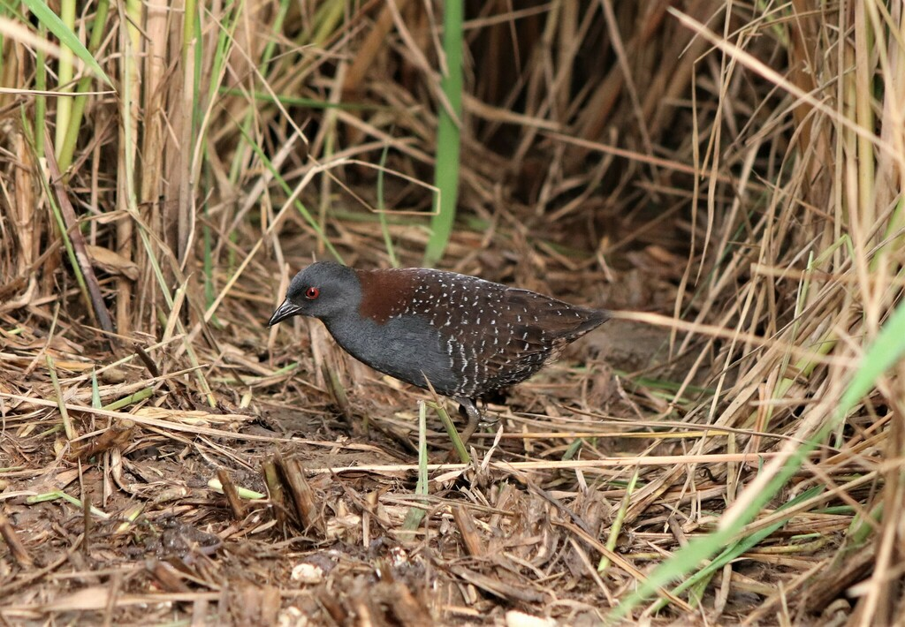
Galveston Island State Park Black Rail Callback Survey Protocol

Objectives
Determine the absence/presence of Eastern Black Rails (BLRA), Laterallus jamaicensis jamaicensis, within the Galveston Island State Park (GISP) boundaries. Habitat management at GISP includes the use of prescribed burns to manage brush and wildfire fuels. The park is divided into 15 Burn Management Units. Each Unit is typically burned every 3 to 5 years. The potential BLRA occupancy of these Units has significant influence on the Park’s Fire Management Plan. Data collected from this study will include but is not limited to:
- What Management Units have BLRA detections?
- Which occupied Management Units have the highest BLRA density and use?
- What habitats and habitat characteristics are being utilized by BLRA at Galveston Island State Park? When? Where? Why?
- What other rail/marsh species are co-occurring with BLRA?
The data collected will be used to modify and update the Galveston Island state Park Fire Management Plan, monitor BLRA response to natural events, park use, and restoration efforts, provide valuable data to researchers studying range-wide BLRA populations and habitat use, and lay a baseline for future population dynamics research.

Equipment
All equipment is the property of Galveston Island State Park and is intended for the express purpose of the Black Rail Callback Surveys conducted at the park. Surveyors will have access to the necessary equipment at the Morgan Building in the Maintenance Yard. Lock combinations will be provided at Surveyor Training Sessions.

Backpack:
Location: The Morgan Building next to the Gas Pump in the Maintenance Yard.
Contents:
- 1 Clipboard
  - Vehicle Windshield Sign (Figure 1)
  - Datasheets (Figure 2)
  - Protocols
  - Reference Codes and Definitions (Figure 3)
  - Maps (Figure 5)
  - Landmark Distance Reference (Figure 6)
  - Writing Utensils
  - Sunrise/Sunset Chart
- 1 Bluetooth Stereo Pop Voice Speaker
- 1 Kestrel Anemometer
- 1 Compass with Mirror
- 2 Pairs of Snake Guards (one short and one long)
- 1 Can of Bug Repellent
- 2 Headlamps (Rechargeable)
- 1 Garmin GPS Unit

Phone:
Surveyors will have to use personal cell phones. These will need to be Smart Phones that have access to navigation apps, Bluetooth, and Email. An email packet will be sent to each surveyor containing all the necessary document files, protocols, and downloads.

Email Packet:
Document Files:
- Black Rail Call Back Survey Protocols
- Management Unit Map (for Avenza)
Downloads:
- Black Rail Callback Audio File – Also available at the FWS Website https://www.fws.gov/EasternBlackRailSurveyProtocol
- Coordinates for Survey Points – KMZ files
- Map to Maintenance Yard and Parking Lot
Link:
- ROHV Training

Apps for Phones:
- Navigation Apps (Options)
  - Google Maps
  - Google Earth
  - Avenza Maps (Free Version)
- Optional Bird Identification Apps
  - Merlin Bird ID
  - Sibley eGuide to Birds
  - BirdNET
  - iNaturalist
NOTE: Bird Song Identification Apps are not 100% accurate and may be used to verify or assist with identifying bird calls but should not be considered a substitute for the surveyor’s identification skills.

Pairing Phone with Speaker:
- Turn on the Pop Voice Bluetooth Speaker by pressing the top button until the blue light is on.
- Turn on Phone’s Bluetooth in Settings.
- Select PoPvoice-Go from pairing selection.
- Open Black Rail Audio File.

Audio Recording Units (ARUs):
These units will be placed by Texas Parks and Wildlife Department personnel; however, surveyors may be asked to monitor the units and collect data. Protocols for ARUs be included in a separate document.

Game Cameras:
These units will be placed by Texas Parks and Wildlife Department personnel; however, surveyors may be asked to monitor the units and collect data. Protocols for Game Cameras be included in a separate document.

Vegetation Survey Equipment:
This equipment will be used to measure habitat characteristics and type where Black Rails are heard within the Galveston Island State Park. Protocols for vegetation surveys are included in a separate document.
- Daubenmire Frame – A 1 m² PVC frame marked in quadrants used to measure vegetation density and composition.
- Tape Measure – measures distance from the center point.
- Yard stick – measures the vegetation height.

Procedure for Callback Surveys
Surveys will be conducted according to the crepuscular protocol outlined in Eastern Black Rail Call-Response Survey Protocol for Range-Wide Monitoring by USFWS. This document is available at https://www.fws.gov/EasternBlackRailSurveyProtocol. The Survey Season will begin mid-February and continue for 16 weeks to mid-June. The Survey Period will be every other week to avoid overexposure or habituation to the recorded Black Rail calls. If conditions do not allow for surveys on the planned date, the survey should be attempted again within the Survey Period up to 7 days prior to the next survey date. Surveys will be performed twice a day for each set of points, one time from half an hour before sunrise until 3 hours after, and again from 3 hours before sunset to half an hour after. Consult Sunrise/Sunset Chart for these times.
There is a total of 22 Survey Points that are distributed throughout the Park at least 400 meters apart, the distance that it is assumed a Black Rail Call can be detected. This functionally allows for the entire Park to be surveyed. Survey Points will be broken up into groups that can conceivably be done in a Survey (see Figure 5): The Bayside Survey Points (blue), the Prairie Survey Points (green), and the Beachside Survey Points (yellow). The combined set up, breakdown, and 10-minute survey period should not exceed a total of 15 minutes. Travel times between points will vary but should also not exceed 15 minutes. All points will be surveyed at least 7 days apart and surveyed at least 6 times (both dawn and dusk) during the Survey Season.
NOTE: DO NOT conduct surveys when average windspeed exceeds 13 mph or 11.3 knots, during sustained rain, or dense fog. Postpone if possible and perform the survey at that point(s) another day within the survey window. If unable to conduct the survey as scheduled for any other reason (illness, appointment, etc.) please notify the Resource Ranger as soon as possible to reschedule or contact a substitute. Contact information will be provided during training.

Step by Step
- Arrive at the park 15 to 30 minutes prior to the start of the survey. The first Survey should start at the time listed on the Volunteer Sign-up Sheet. Upon arrival at the park, pick up the Backpack from the Morgan Building in the Maintenance Yard. Combinations will be provided during training.
- Check the backpack to make sure that all necessary equipment is present and operational.
- Navigate to the first Survey Point using either the app on your phone, the Garmin GPS Unit in the Backpack (pre-programmed) or reference Figure 4.
  - Personal vehicles must remain on paved roads and surfaces.
  - When Roadside Parking: The Rule is 2 Tires ON, 2 Tires OFF.
  - Approved UTVs for the Prairie Survey Points Group must remain on either roads and paved surfaces or established trails. Training to operate a TPWD UTV will be provided in the Volunteer Email.
  - Place the TPWD WILDLIFE SURVEY IN PROGRESS sign on the dash of personal vehicle and ensure it is visible through the windshield.
  - Do not drive a vehicle closer than 100 feet of the Survey Point.
  - Walk to the Survey Point.
- Turn on the speaker and connect phone via Bluetooth and begin playing survey audio.
- During the 15 second preparation section and subsequent 5 minutes of passive silence of the recording, set up the speaker on the tripod, and prepare the data sheet Figure 2.
- Fill in the name of the surveyor, the name of the survey point, date, and time started.
- Record the noise level according to the protocol on the data sheet or use a decibel reader app to measure the ambient noise.
- Record the weather conditions according to the protocol on the data sheet.
- Use the Kestrel to measure the windspeed and temperature.
- Remain as silent as possible during the remainder of the passive period, record any rail calls detected during that time. Record species, number of individuals, direction (bearing), and distance.
- As the different calls play through on the recording, listen for any response.
- Record each rail response on a different line and the type of call response.
- Use the compass to determine the bearing (direction) of each rail from the survey point and estimate the distance based on landmarks close to the source of the sound Figure 6.
- After the audio has completed, replace all items in the backpack and proceed to the next point. Use the same datasheet at the next Survey Point unless filled and then start page 2, noting the page number at the top of the datasheet. The same data sheet can be used for dawn and dusk surveys. The same datasheets may be used for the dawn and dusk Surveys of the same Survey Points but each set of Survey Points should be on a separate sheet.
- At the conclusion of each survey, return the Backpack to the Morgan Building in the Maintenance Yard and ensure that the building is locked, and the gate is locked after business hours.
- At the conclusion of the dawn surveys, turn in the previous day’s survey to the Nature Center or Beachside Headquarters.

What if I hear a BLRA Before or After a Survey or Between Survey Points?
- Any BLRA calls heard before or after the callback recording AT the Survey Point should be recorded just like those heard during and mark as “Outside Survey” on the data sheet with a Y in that column.
- If a Black Rail is heard between points, use the Garmin GPS Unit to take a point from where you hear it. Title the point as BLRA-DATE-DESTINATION POINT. Example: BLRA021725GISP001. Take a bearing and estimate the distance from the point and record in the NOTES section of the GPS Point properties screen. Record on datasheet using point title as usual. If the same BLRA is heard at the Survey Point, record as “heard from previous point.”

References
Eastern Black Rail Call-Response Survey Protocol, version 1.0. 2023. Christy Hand, Amy Schwarzer, Maureen Correll, Alix Godar, Heather Levy, Liza Rossi, Michelle Stantial, Morgan Wolf. Eastern Black Rail Protocol Team.

Figure 1: Vehicle Windshield Sign
TPWD WILDLIFE SURVEY IN PROGRESS

Figure 2: BLRA Callback Survey Datasheet

Figure 3: Codes and Definitions

Species Codes
BLRA = Black Rail
CLRA = Clapper Rail
KIRA = King Rail
VIRA = Virginia Rail
YEAR = Yellow Rail
SORA = Sora

Background Noise
0 = No noise (silent)
1 = Faint noise (distraction at most)
2 = Moderate noise (probably cannot hear a BLRA at 100 m for more than 30 seconds)
3 = Loud noise (probably cannot hear a BLRA at 50 m for more than 30 seconds)
4 = Intense noise (probably cannot hear a BLRA at 25 m for more than 30 seconds)

Cloud Cover
0 = Clear or negligible cloud cover
1 = Partly cloudy or variable cloud cover
2 = Cloudy or overcast
4 = Fog or smoke
5 = Drizzle
8 = Showers

BLRA Detection
0 = No BLRA Detected
1 = BLRA Heard
S = BLRA Seen
1S = BLRA Seen and Heard

BLRA Calls
KKD/KKR = kickee-doo/kic-kic-kerr
GRR = grr-grr-grr
CHR = churt
INK = ink-ink-ink

Figure 4: Survey Point Name and Coordinates

Survey Point Name | Latitude | Longitude
GISPBLRAS001 | 29°12’30.95”N | 94°57’15.78”W
GISPBLRAS002 | 29°12'17.01"N | 94°57'13.53"W
GISPBLRAS003 | 29°12'8.23"N | 94°57'5.95"W
GISPBLRAS004 | 29°11'55.98"N | 94°57'10.12"W
GISPBLRAS005 | 29°12'1.60"N | 94°57'18.62"W
GISPBLRAS006 | 29°12'22.1"N | 94°57'45.3"W
GISPBLRAS007 | 29°12'6.34"N | 94°57'52.63"W
GISPBLRAS008 | 29°11'53.00"N | 94°57'55.00"W
GISPBLRAS009 | 29°11'57.12"N | 94°58'10.47"W
GISPBLRAS010 | 29°12'4.32"N | 94°57'36.01"W
GISPBLRAS011 | 29°11'49.04"N | 94°57'41.57"W
GISPBLRAS012 | 29°11'41.89"N | 94°57'57.17"W
GISPBLRAS013 | 29°11'31.58"N | 94°58'13.83"W
GISPBLRAS014 | 29°11'36.71"N | 94°58'27.61"W
GISPBLRAS015 | 29°11'21.18"N | 94°58'27.37"W
GISPBLRAS016 | 29°11'20.77"N | 94°58'4.53"W
GISPBLRAS017 | 29°11'31.17"N | 94°57'49.99"W
GISPBLRAS018 | 29°11'47.87"N | 94°57'24.18"W
GISPBLRAS019 | 29°11'47.13"N | 94°57'3.22"W
GISPBLRAS020 | 29°11'38.59"N | 94°57'16.42"W
GISPBLRAS021 | 29°11'19.42"N | 94°57'48.34"W
GISPBLRAS022 | 29°11'7.05"N | 94°58'3.59"W

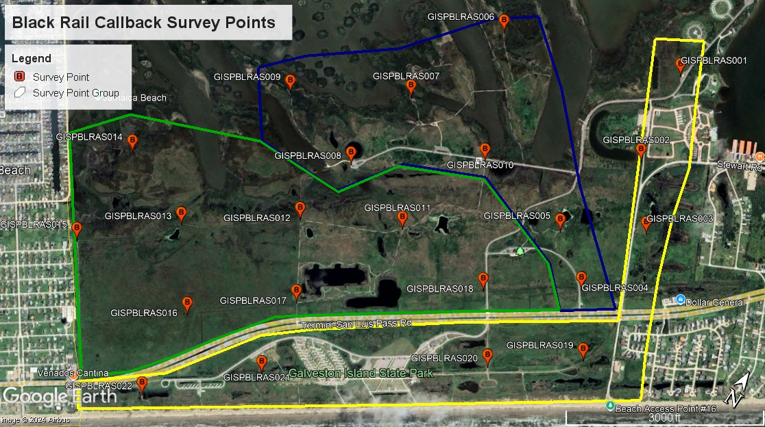
Figure 5: Map of Survey Points

Figure 6: Landmarks to Estimate Distance
Survey Point | Landmark | Distance
GISPBLRAS001 | Edge of Tent Campground  Park Host Site  Maintenance Shop  Inlet | 155 meters  70 meters  220 meters  100 meters
GISPBLRAS002 | Maintenance Shop  Stewart/13 Mile Road Fork  Park Road 66  Day Use | 220 meters  100 meters  270 meters  280 meters
GISPBLRAS003 | Gate Entry to Point  Neighborhood  FM 3005 | 60 meters  250 meters  365 meters
GISPBLRAS004 | Nature Center  Old Exit Road  FM 3005  13 Mile Road | 330 meters  435 meters  90 meters  190 meters
GISPBLRAS005 | Nature Center  Bird Blind/Deck Viewing Platform  North to Park Road 66  13 Mile Road  FM 3005 | 200 meters  140 meters  175 meters  325 meters  370 meters
GISPBLRAS006 | Observation Tower  Eskimo Curlew Statue  Trail and Boardwalk Intersection  East to Oak Bayou | 280 meters  310 meters  265 meters  200 meters
GISPBLRAS007 | Eskimo Curlew Statue  Near Observation Tower  Far Observation Tower  Oak Mott | 285 meters  160 meters  565 meters  250 meters
GISPBLRAS008 | Kayak Launch  Oak Mott  Prairie Trail  Slough | 120 meters  200 meters  150 meters  115-415 meters
GISPBLRAS009 | Kayak Launch  Bayou  Point GISPBLRAS007  Round Pond | 75 meters  60 meters  550 meters  355 meters
GISPBLRAS010 | Parking Lot  Eskimo Curlew  Park Road 66 Junction  Near Observation Tower | 165 meters  335 meters  425 meters  285 meters
GISPBLRAS011 | Trail Head  Amoeba Man Pond  FM 3005  Oak Mott Slough | 500 meters  150 meters  388 meters  240 meters
GISPBLRAS012 | Kayak Launch  Oak Mott Slough  Fresh Water Pond Gate/FM 3005 | 270 meters  440 meters  450 meters
GISPBLRAS013 | Crossroads  Jamaica Beach/ GISPBLRAS015  North to Carancahua Bayou | 550 meters  487 meters  200 meters
GISPBLRAS014 | Carancahua Bayou  Jamaica Beach  Marsh Wetlands | 305 meters  290 meters  230 meters
GISPBLRAS015 | FM 3005  Marsh N/NW  Crossroads | 650 meters  175 meters  1035 meters
GISPBLRAS016 | FM 3005  Fresh Water Pond Gate  Jamaica Beach  Prairie Trail | 170 meters  500 meters  495 meters  420 meters
GISPBLRAS017 | FM 3005  Crossroads  Small Freshwater Pond | 75 meters  380 meters  225 meters
GISPBLRAS018 | FM 3005  Exit Road Entrance  Nature Center  East to Park Road 66 | 100 meters  170 meters  255 meters  440 meters
GISPBLRAS019 | 13 Mile Road  FM 3005  Beach  Water Storage Tank | 135 meters  175 meters  190 meters  80 meters
GISPBLRAS020 | FM 3005/Park Entrance  HQ  Beach  Day Use Restroom | 210 meters  265 meters  165 meters  350 meters
GISPBLRAS021 | RV Campground  Tent Campground  Beach  Dry Camping | 220 meters  60 meters  155 meters  180 meters
GISPBLRAS022 | 15 Mile Road  Beach  Dry Camping  FM 3005 | 290 meters  60 meters  185 meters  75 meters

